VISUALISATION CRITIQUE
Hospitalised Injuries from Road Crashes
COS30045 - Data Visualisation | Swinburne University

Student: Nguyen Huyen Minh Nhat
Student ID: 105550225 – SWH02356
Due date: 18 October 2026, 23:59

Contents
1. Introduction 2
2. Data Processing and Governance 3
3. Visualisation Design 4
3.1 Chart selection and data encoding 4
3.2 Colour, labels and visual hierarchy 5
3.3 Interactivity and usability 5
4. Recommendations 6
References 7

1. Introduction
The Hospitalised Injuries from Road Crashes dashboard presents road-crash injuries that resulted in hospital admission in Australia. It does not cover every injury reported after a crash. Its two main views show the number of hospitalised injuries and the rate per 100,000 people, with breakdowns by factors such as age, sex and remoteness (Office of Road Safety, n.d.).
The dashboard seems most useful to road-safety researchers, policy staff and people looking for patterns in serious injuries. A researcher might compare age groups over time, while a member of the public might check whether injury rates differ between cities and remote areas. For either audience, it is important to separate counts from rates. More admissions in a densely populated area do not necessarily mean a higher risk for each resident.
I examine how clearly the dashboard communicates those differences, how the underlying data is explained, and where the presentation could mislead a reader. I focus on the charts and their labels, colour, navigation and glossary, then suggest changes that could be made without replacing the data.
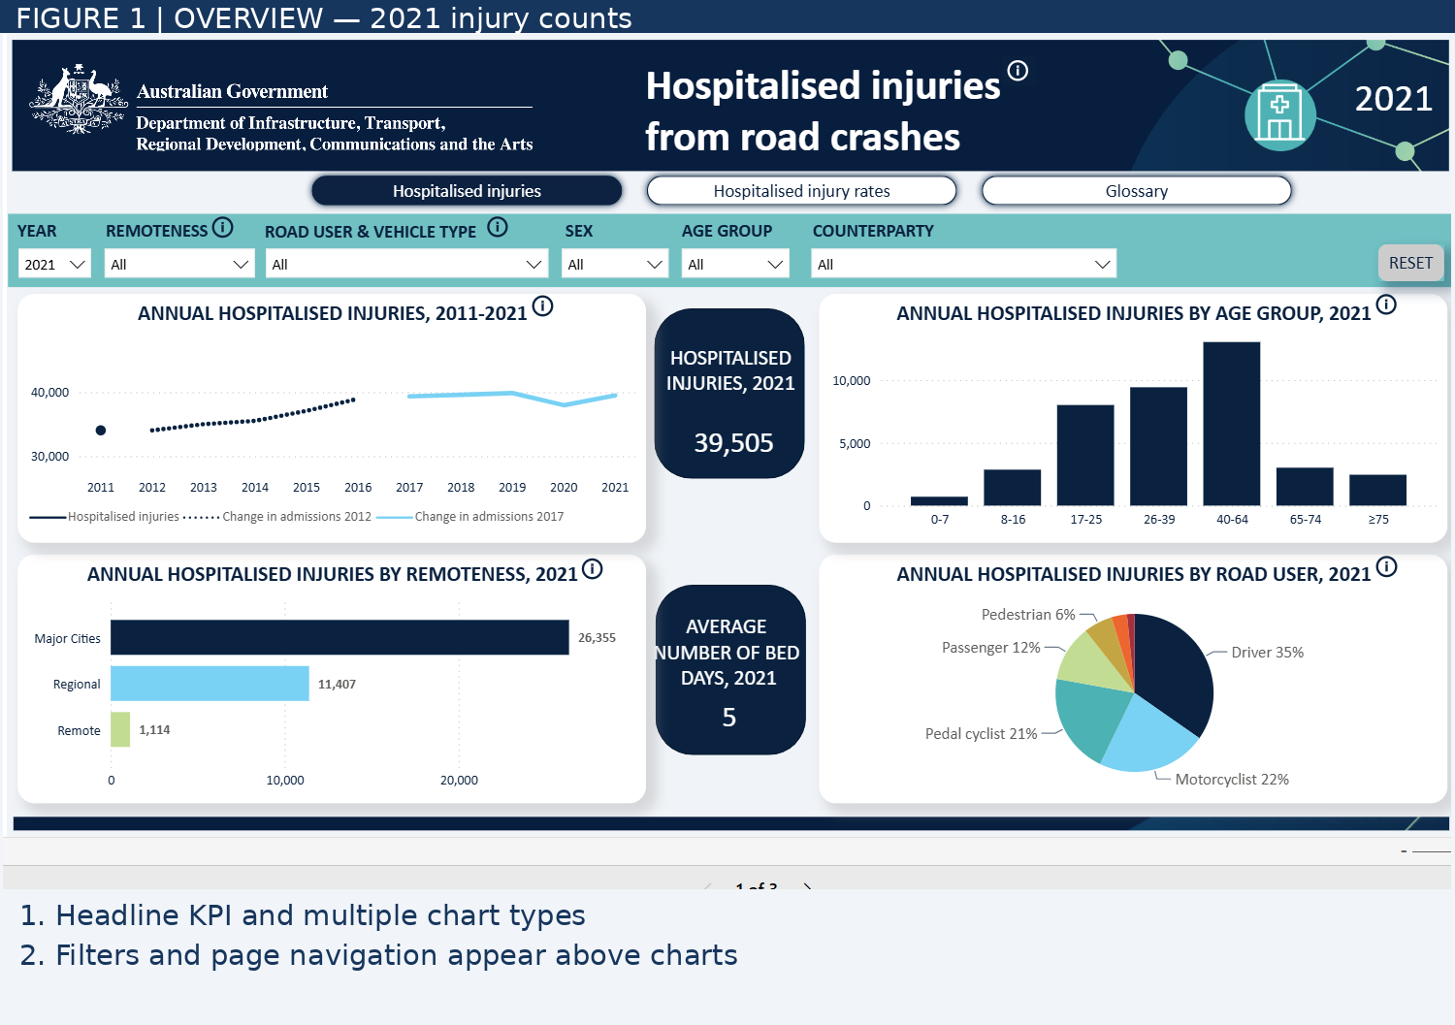
Figure 1. Overview of the assigned dashboard: 2021 hospitalised-injury counts, charts and filter controls. Source: assigned Power BI dashboard (2021 view).

2. Data Processing and Governance
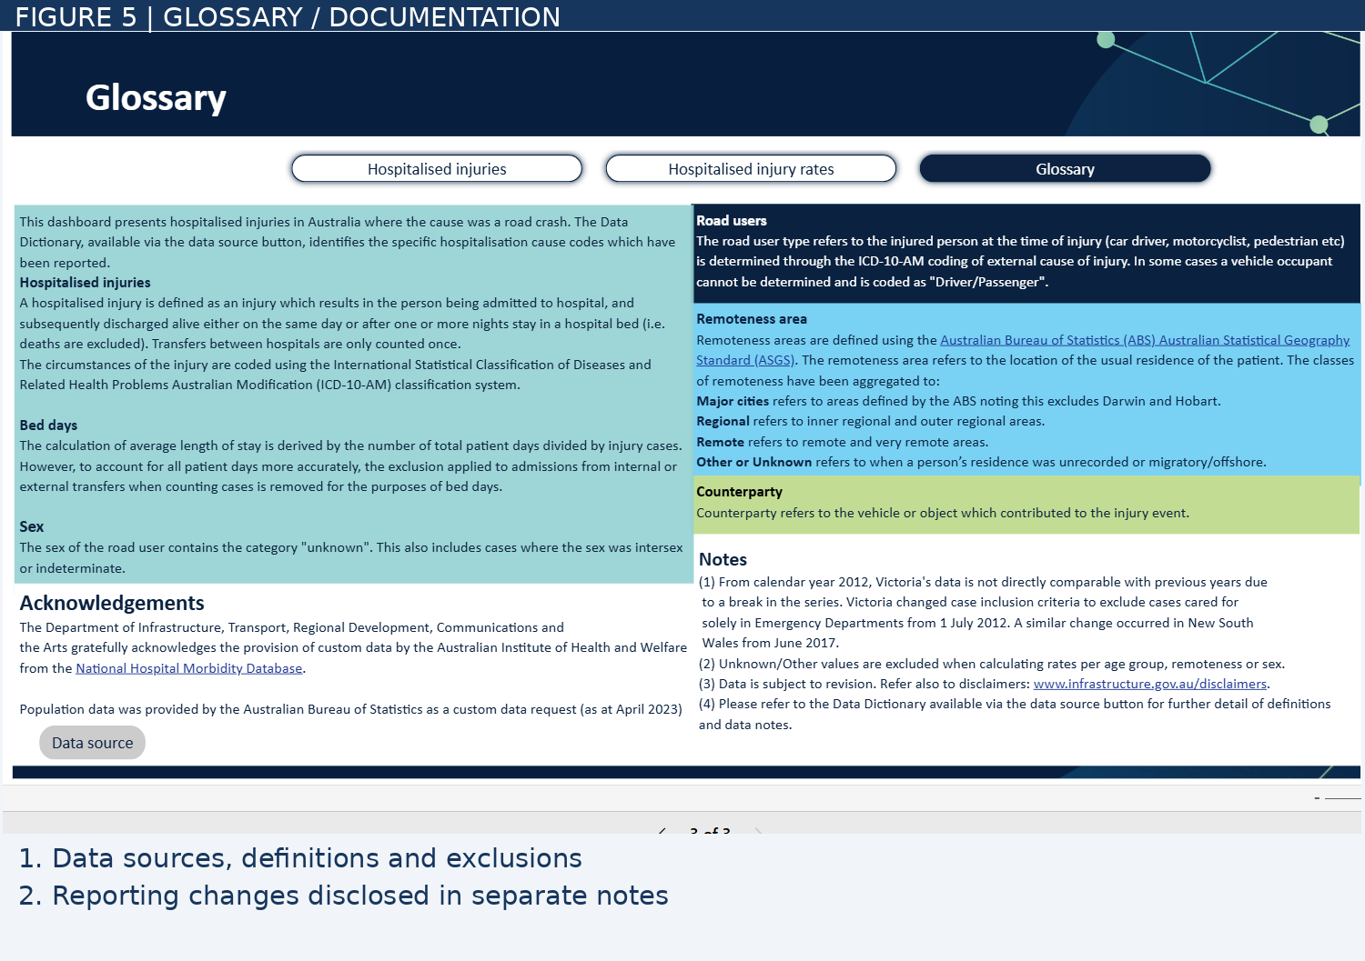
Figure 2. Glossary page: definitions, data provenance and methodological notes. Source: assigned Power BI dashboard (2021 view).
The glossary identifies the Australian Institute of Health and Welfare (AIHW) National Hospital Morbidity Database as the source of the injury figures. The population estimates used for rates come from the Australian Bureau of Statistics (ABS). These are credible sources, and I appreciate that the glossary explains where the numbers come from. However, the dashboard gives only a summary of the processing. Someone trying to reproduce the figures would still need to consult the linked Data Dictionary and source documentation.
The definition of a 'hospitalised injury' deserves particular attention. It refers to a road-crash injury followed by a hospital admission, with the patient discharged alive, whether after one day or several nights. A transfer between hospitals is counted as one case, and road-user categories rely on ICD-10-AM codes. These details make the measure more precise, but they also limit what it can tell us. The figures exclude deaths and do not represent every person injured in a road crash.
The reporting changes are the most serious limitation for reading the trend. The glossary says Victoria changed its reporting criteria in July 2012 and New South Wales did so in June 2017. After those changes, cases treated only in emergency departments were no longer included in the relevant reporting. Because these changes occurred in particular states, a movement in the national series around those years should not automatically be read as a real change in road safety. The line chart signals different periods, but I only understood why they mattered after checking the glossary (Figure 3).
The notes also warn that some figures can be revised. Records marked 'Other/Unknown' are left out of certain rates by age, sex or remoteness. That avoids assigning people to groups without evidence, but it may affect how representative those comparisons are. I could not find a clear count of excluded records alongside the charts. Without it, readers cannot easily judge how much information is missing from a particular breakdown.
The dashboard shows aggregated data rather than patient-level records, which is appropriate for a public site about hospital admissions. Still, the screenshots do not show how the original databases handle consent, access or other privacy controls, so I cannot judge those processes. My concern here is mainly transparency: the definitions, exclusions and reporting changes are documented, but they are not always visible when someone is looking at a chart.

3. Visualisation Design

3.1 Chart selection and data encoding
The dashboard uses summary figures, a time-series line chart, bar charts and a pie chart. Most of these choices fit the questions being asked. The line chart gives a sense of change over time, while the bars help compare categories. The issue is less about choosing the wrong chart type and more about what a reader might miss while interpreting it.
The figure of 39,505 hospitalised injuries in 2021 draws attention straight away. The nearby summary of five average bed days also gives a sense of the burden on hospitals. These large figures make the page easy to enter, although the definition of 'hospitalised injury' receives much less attention. Someone who skips the glossary could mistake 39,505 for the total number of people injured in road crashes that year.
A line chart is a good fit for showing the 2011–2021 pattern. What I found harder to follow was the change in line styling around 2012 and 2017. Those points relate to the reporting changes described earlier, but the explanation is not obvious from the chart itself. Brief notes beside the relevant years, naming Victoria and New South Wales, would help readers understand why comparisons across those periods need care (Figure 3).
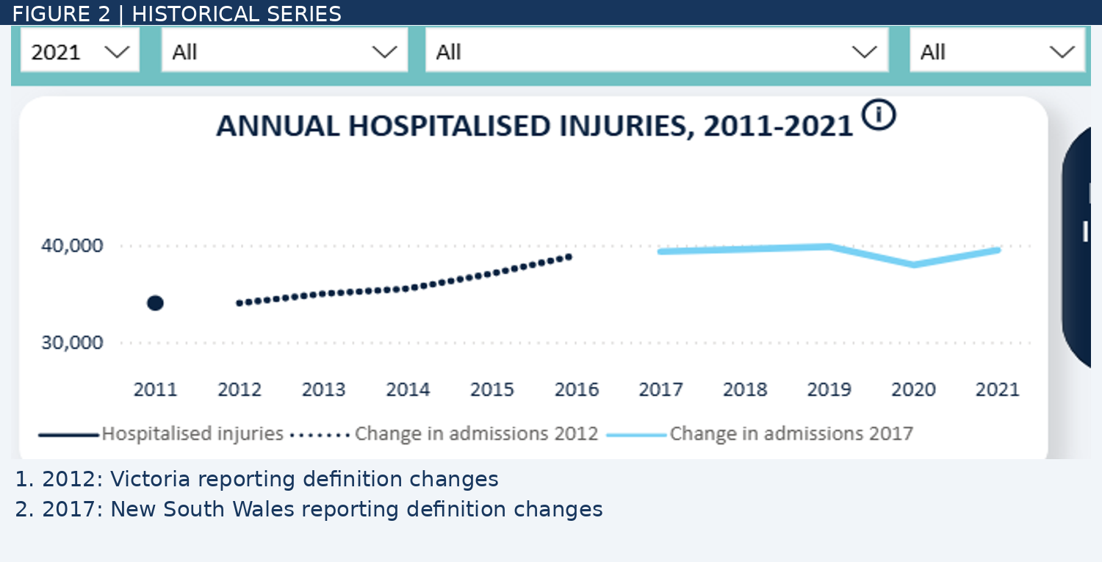
Figure 3. Time-series chart with annotations for the 2012 and 2017 reporting changes. Source: assigned Power BI dashboard (2021 view).
The remoteness views show why counts and rates should be read together. In 2021, Major Cities recorded 26,355 hospitalised injuries, Regional areas 11,407, and Remote areas 1,114. On counts alone, Remote areas seem to have the smallest problem. Yet their injury rate is 224.6 per 100,000 people, compared with 171.6 in Regional areas and 142.1 in Major Cities (Figure 4). That difference is one of the strongest insights in the dashboard. I would make the units more prominent so a reader does not compare a count on one page with a rate on another as though they were the same measure.
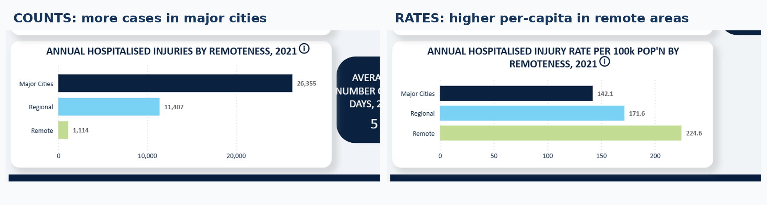
Figure 4. Hospitalised-injury counts (left) and rates per 100,000 people (right) by remoteness, 2021. Source: assigned Power BI dashboard.
The road-user pie chart groups injuries among drivers, motorcyclists, cyclists, passengers and pedestrians. I can see the biggest shares quickly, but the smaller slices and their labels take more effort to compare. A sorted horizontal bar chart would work better for this particular question. It would use a common baseline, keep the category names readable and make small differences easier to see (Figure 5).
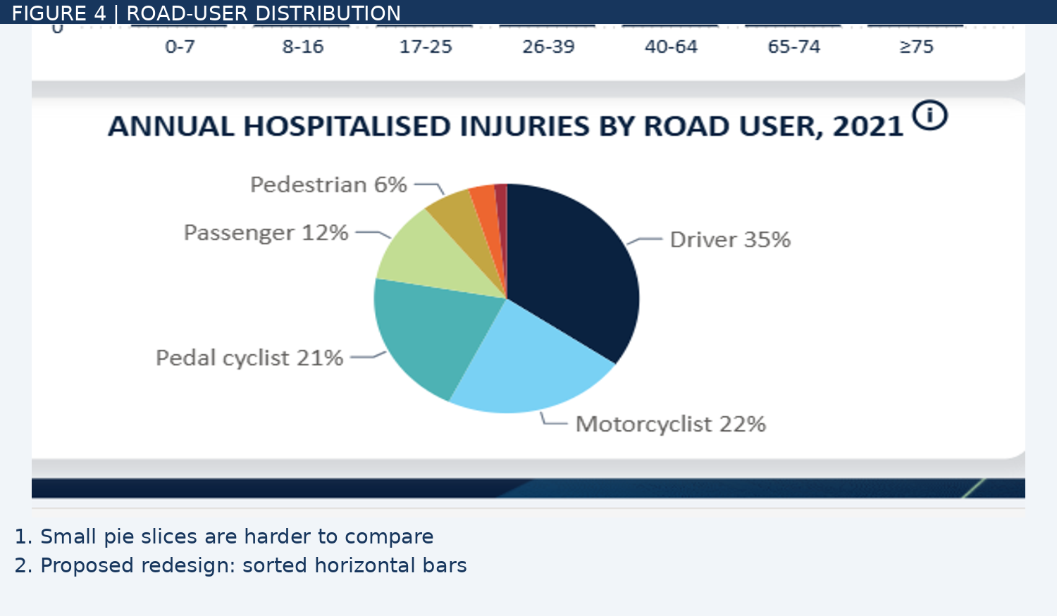
Figure 5. Road-user distribution. The smaller pie slices are difficult to compare precisely. Source: assigned Power BI dashboard (2021 view).

3.2 Colour, labels and visual hierarchy
The overall layout is easy to scan. The headline numbers stand out, and the supporting charts sit in a fairly straightforward arrangement. Several charts show values directly, which saves the reader from estimating everything from an axis. I would keep those features in a redesign.
Colour becomes more difficult when it is doing the work of an explanation. In the trend chart, a change of line style hints that the data is different, but it does not tell a new reader what happened. Text annotations would make that meaning clearer and avoid relying on colour or line style alone. I would also test whether small labels and chart elements remain distinguishable at different screen sizes. The supplied screenshots are not enough to establish accessibility compliance, but the W3C guidance on non-text contrast offers a useful check (World Wide Web Consortium, n.d.).

3.3 Interactivity and usability
The visible controls allow readers to choose a year and filter by demographic or road-user characteristics. There is also a Reset option. This should let someone move from the national overview to a more specific group without needing a separate report. The counts, rates and glossary pages are clearly signposted in the screenshot.
I would still want to check what happens after several filters have been applied. If the selected values are easy to overlook, someone may take a filtered result for the national total. Tooltips might help with definitions or exact values, but that depends on how they are implemented. I have only reviewed the supplied screenshots, so I cannot claim the live controls or keyboard navigation are faulty.
The glossary answers many of the questions raised by the charts, but readers have to choose to open it. By then they may already have reached a conclusion about the trend. Putting a short warning under the line chart, with a link to the full explanation, would make the data limitation harder to miss without crowding the page.
For me, the dashboard works best when counts and rates are considered side by side. Its main weakness is that readers have to move away from the charts to find some of the information needed to interpret them properly.

4. Recommendations
I would start with the time-series chart. Mark July 2012 (Victoria) and June 2017 (New South Wales), and add a short explanation of the reporting changes. A link to the glossary can provide the detail. That would make the interrupted line styling useful rather than leaving readers to guess what it means.
For the road-user breakdown, a sorted horizontal bar chart would make comparisons easier, particularly between the smaller categories. Showing exact values or percentages at the end of each bar would also reduce the need to estimate slice sizes. The pie chart is not wrong, but it is less effective for comparing several similarly sized groups.
A second priority is to move the most relevant definitions closer to the visuals. The counts page should explain briefly what qualifies as a hospitalised injury. The rates page should state that results are per 100,000 people and note when 'Other/Unknown' records are excluded. These could be one-sentence notes with links to the glossary, rather than long blocks of text.
I would then test the filters and navigation with a few realistic tasks: select an age group, compare counts with rates, and return to the original view. The active filter values and the Reset option should remain easy to find throughout. I would also check keyboard access, tooltips and the small-screen layout before making any claims about their usability.
The dashboard already has the information needed to explain an important road-safety issue. These changes would mainly help readers understand what the figures measure, where comparisons are risky, and when they should look beyond the headline number.

References
Office of Road Safety. (n.d.). Injuries data. https://www.officeofroadsafety.gov.au/data-hub/serious-injuries-data
World Wide Web Consortium. (n.d.). Understanding SC 1.4.11: Non-text contrast (Level AA). Web Accessibility Initiative. https://www.w3.org/WAI/WCAG22/Understanding/non-text-contrast.html
Scope note. Figures are based on the screenshots supplied for the assigned Power BI dashboard. Observations about the visual design are based on those screenshots; filter behaviour, tooltips, keyboard access and mobile layout have not been independently tested.

